Project 1.B

- Project Description
Figure 1 shows an ER diagram for University database. This is the same in Project 1.A.

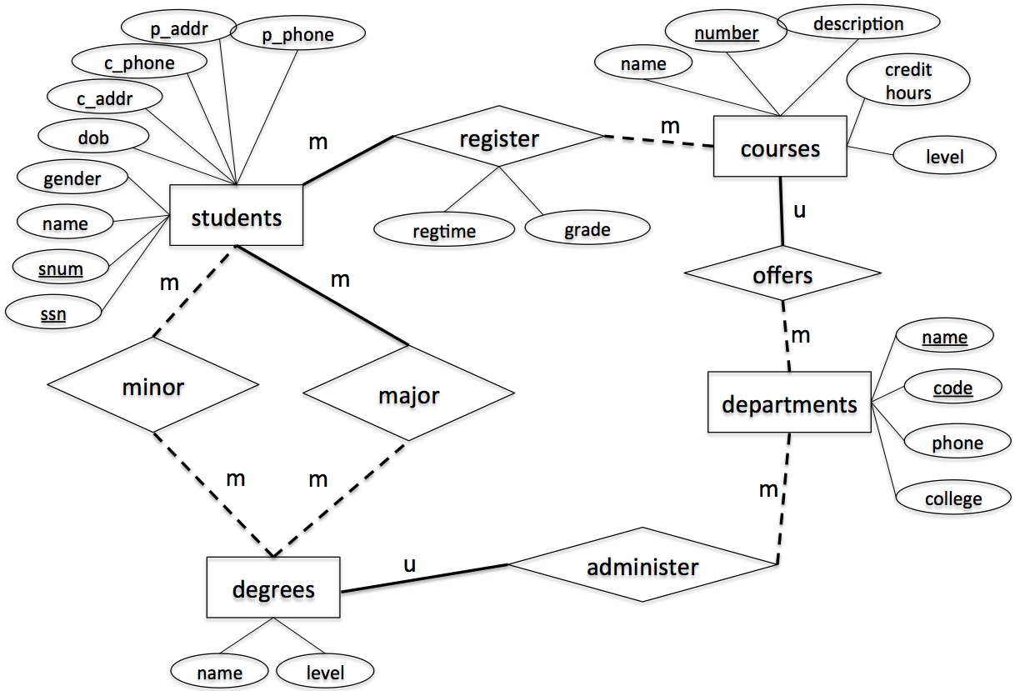
Figure 1. ER-diagram
This project is to implement the above design using a relational data model. Specifically, you are asked to write the following Java programs using JDBC connection to connect MySQL database to Java programs.

- CreateTables.java [Points: 15]
After execution, your program must create the following tables. Each table must be created with the table name, attribute names and corresponding types and length as specified. Also, make sure to specify primary key, candidate key and foreign key (if any), accordingly.
- students
  - Attribute, type and length: snum: integer, ssn: integer, name: varchar(10), gender: varchar(1), dob: datetime, c_addr: varchar(20), c_phone: varchar(10), p_addr: varchar(20), p_phone: varchar(10)
  - Primary key: ssn
  - Candidate key: snum
  - Foreign key: N/A
- departments
  - Attribute, type and length: code: integer, name: varchar(50), phone: varchar(10), college: varchar(20)
  - Primary key: code
  - Candidate key: name
  - Foreign key: N/A
- degrees
  - Attribute, type and length: name: varchar(50), level: varchar(5), department_code: integer
  - Primary key: name, level
  - Candidate key: N/A
  - Foreign key: department_code refers to code in table departments
- courses
- Attribute, type and length: number: integer, name: varchar(50), description: varchar(50), credithours: integer, level: varchar(20), department_code: integer
- Primary key: number
- Candidate key: name
- Foreign key: department_code refers to code in table departments
- register
- Attribute, type and length: snum: integer, course_number: integer, regtime: varchar(20), grade: integer
- Primary key: snum, course_number
- Candidate key: N/A
- Foreign key: snum refers to snum in table students, course_number refers to number in table courses
- major
- Attribute, type and length: snum: integer, name: varchar(50), level: varchar(5)
- Primary key: snum, name, level
- Candidate key: N/A
- Foreign key: snum refers to snum in table students, name & level refer to name & level in table degrees
- minor
- Attribute, type and length: snum: integer, name: varchar(50), level: varchar(5)
- Primary key: snum, name, level
- Candidate key: N/A
- Foreign key: snum refers to snum in table students, name & level refer to name & level in table degrees

- InsertRecords.java [Points: 15]
After execution, your program must insert the following records to the appropriate tables created by CreateTables.java.

- students

snum | ssn | name | gender | dob | c_addr | c_phone | p_addr | p_phone
1001 | 654651234 | Randy | M | 2000/12/01 | 301 E Hall | 5152700988 | 121 Main | 7083066321
1002 | 123097834 | Victor | M | 2000/05/06 | 270 W Hall | 5151234578 | 702 Walnut | 7080366333
1003 | 978012431 | John | M | 1999/07/08 | 201 W Hall | 5154132805 | 888 University | 5152012011
1004 | 746897816 | Seth | M | 1998/12/30 | 199 N Hall | 5158891504 | 21 Green | 5154132907
1005 | 186032894 | Nicole | F | 2001/04/01 | 178 S Hall | 5158891155 | 13 Gray | 5157162071
1006 | 534218752 | Becky | F | 2001/05/16 | 12 N Hall | 5157083698 | 189 Clark | 2034367632
1007 | 432609519 | Kevin | M | 2000/08/12 | 75 E Hall | 5157082497 | 89 National | 7182340772

- departments

code | name | phone | college
401 | Computer Science | 5152982801 | LAS
402 | Mathematics | 5152982802 | LAS
403 | Chemical Engineering | 5152982803 | Engineering
404 | Landscape Architect | 5152982804 | Design

- degrees

name | level | department_code
Computer Science | BS | 401
Software Engineering | BS | 401
Computer Science | MS | 401
Computer Science | PhD | 401
Applied Mathematics | MS | 402
Chemical Engineering | BS | 403
Landscape Architect | BS | 404

- major

snum | name | level
1001 | Computer Science | BS
1002 | Software Engineering | BS
1003 | Chemical Engineering | BS
1004 | Landscape Architect | BS
1005 | Computer Science | MS
1006 | Applied Mathematics | MS
1007 | Computer Science | PhD

- minor

snum | name | level
1007 | Applied Mathematics | MS
1005 | Applied Mathematics | MS
1001 | Software Engineering | BS

- courses

number | name | description | credithours | level | department_code
113 | Spreadsheet | Microsoft Excel and Access | 3 | Undergraduate | 401
311 | Algorithm | Design and Analysis | 3 | Undergraduate | 401
531 | Theory of Computation | Theorem and Probability | 3 | Graduate | 401
363 | Database | Design Principle | 3 | Undergraduate | 401
412 | Water Management | Water Management | 3 | Undergraduate | 404
228 | Special Topics | Interesting Topics about CE | 3 | Undergraduate | 403
101 | Calculus | Limit and Derivative | 4 | Undergraduate | 402

- register

snum | course_number | when | grade
1001 | 363 | Fall2020 | 3
1002 | 311 | Fall2020 | 4
1003 | 228 | Fall2020 | 4
1004 | 363 | Spring2021 | 3
1005 | 531 | Spring2021 | 4
1006 | 363 | Fall2020 | 3
1007 | 531 | Spring2021 | 4

- Query.java [Points: 55]
After execution, your program must print out the following information
  - The student number and ssn of the student whose name is "Becky"
  - The major name and major level of the student whose ssn is 123097834
  - The names of all courses offered by the department of Computer Science
  - All degree names and levels offered by the department Computer Science
  - The names of all students who have a minor
- ModifyRecords.java [10]
After execution, your program must modify the following information
- Change the name of the student with ssn = 746897816 to Scott
- Change the major of the student with ssn = 746897816 to Computer Science, Master.
- Delete all registration records that were in “Spring2021”,
- DropTables.java [5]
After execution, your program must delete all tables.

Submission Instruction
Submit all your java programs (*.java) to Canvas. Be sure to
- Name your files as required, i.e., CreateTables.java, InsertRecords.java, Query.java, ModifyRecords.java, DropTables.java;
- Make each of these java files independent executable, i.e., each having its main() method;
- Set user name to be “coms363” and password to be “password” in database authentication.

- Set up working environment using Eclipse (This instruction is based on Windows)
  - Make sure that you have Java JDK installed in your computer, if not, you can get Java JDK at http://www.oracle.com/technetwork/java/javase/downloads/index.html
  - Download and install Eclipse IDE at https://eclipse.org/downloads/ (choose “Eclipse IDE for Java Enterprise Java Developers”)
  - Download and install Connector J at https://dev.mysql.com/downloads/connector/j/
If you use Windows, search for MySQL installer – community app on your computer. If you see the following window, you have Connector J installed. You can also find the install path. If you don’t see Connector/J on the list, then click “Add” on the right, choose “MySQL connectors”, find Connector/J and install it.
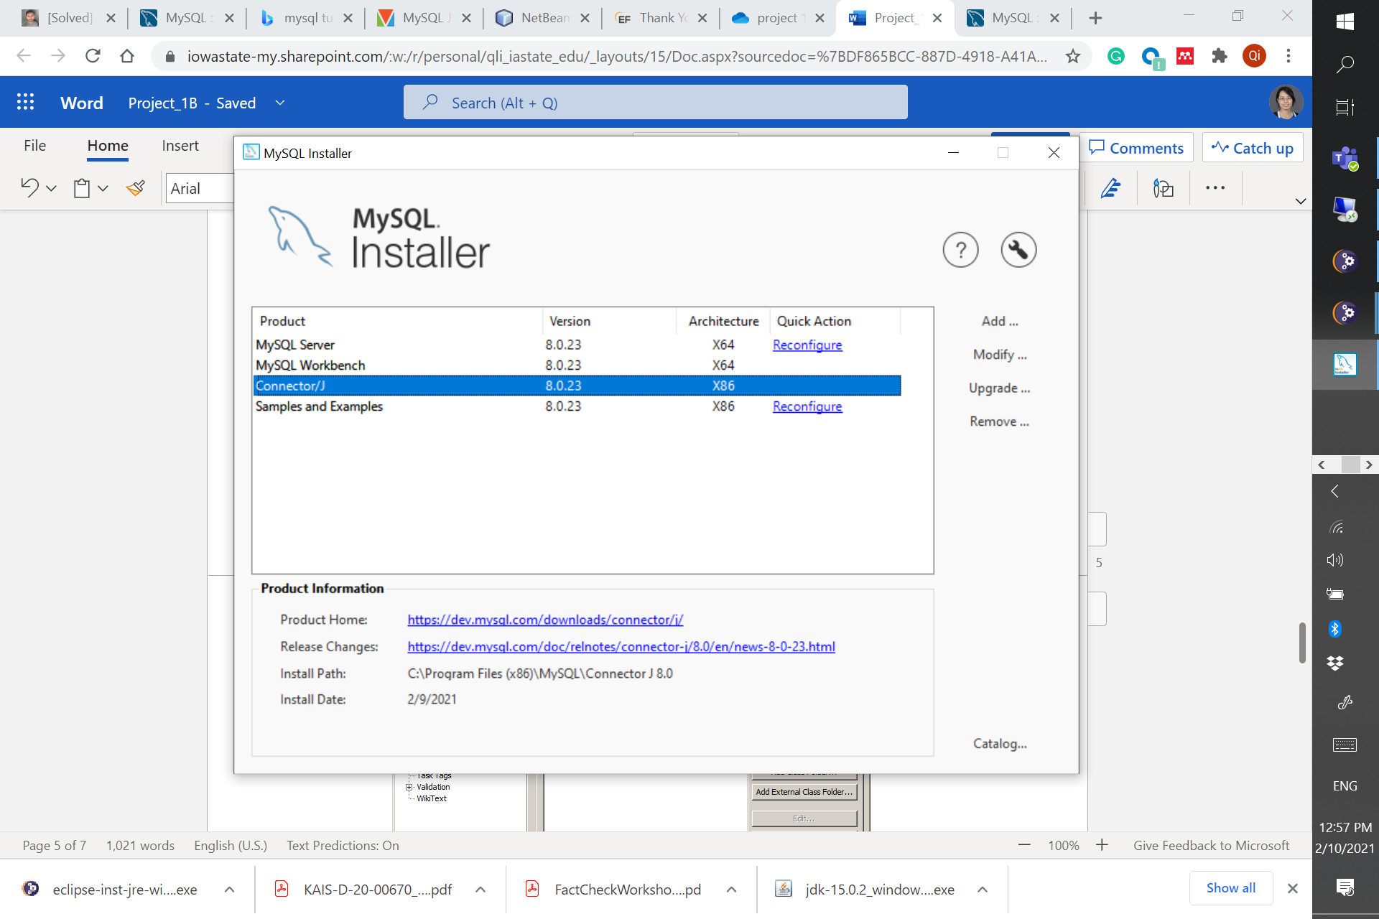
  - Open Eclipse
  - Create new Java project by go to “File > New > Other…” then select “Java Project”
  - Give your Java project a name, then click “next”.
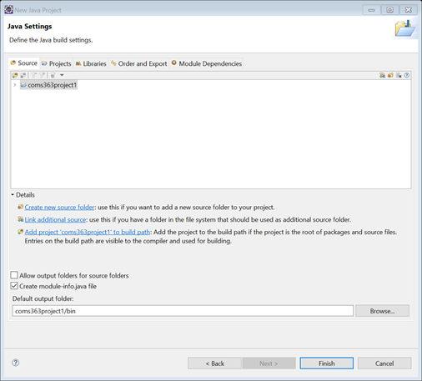
  - Next, add Connector J JAR file to your project build path. Click on “libraries->classpath” and choose “Add External JARs…”
  - Go to directory that you installed Connector J and select Connector J JAR file (this can be vary based on directory you have installed. For Windows, you can find the path in installers). Then click Finish.
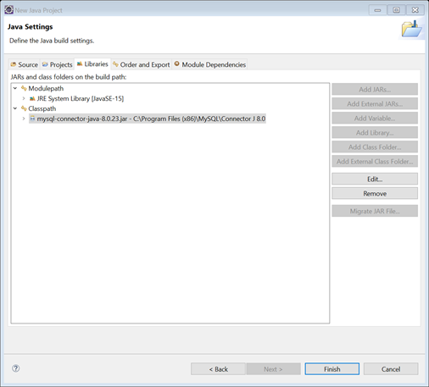

- Examples of Java codes
This link https://docs.oracle.com/javase/tutorial/jdbc/basics/processingsqlstatements.html gives you a tutorial on coding JDBC. For your convenience, we give you some sample code below.

  - Establishing a connection

import java.sql.*;
private static Connection connect = null;
try
{
Class.forName("com.mysql.jdbc.Driver");
//Set up connection parameters
String userName = "[username]";
String password = "[password]";
String dbServer = "jdbc:mysql://mysql.cs.iastate.edu/[schema]";
//Set up connection
connect = DriverManager.getConnection(dbServer,userName,password);
}
Catch(Exception e)
{
}

  - Executing DML & DDL

Statement stmt = null;
stmt = connect.createStatement();
String sql = "INSERT INTO Registration " + "VALUES (100, 'Zara', 'Ali', 18)";
stmt.executeUpdate(sql);

  - Executing SQL query
ResultSet resultSet = null;
String sqlQuery = "";
String outputString = "";
sqlQuery = "SELECT * FROM student";
stmt = connect.createStatement();
resultSet = statement.executeQuery(sqlQuery);
while(resultSet.next())
{
outputString += resultSet.getInt("sid") + "....";
outputString += resultSet.getString("student_name") + "....";
outputString += resultSet.getString("student_email") + "\n";
}

Note:
For testing your code, we will use username= ‘coms363’ and password= ‘password’. To set up this user account, run the following code as root user.

CREATE USER 'coms363'@'localhost' IDENTIFIED BY 'password';
GRANT ALL PRIVILEGES ON *.* TO 'coms363'@'localhost';

Once you run your Java code, you should see updates on MySQL (remember to refresh SCHEMAS)

